Manual

1. Double click the exe file

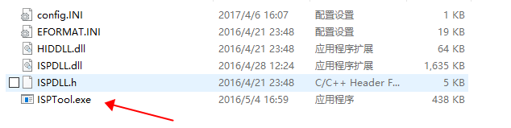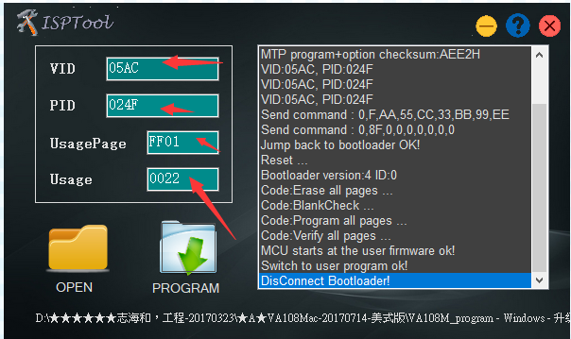

1. Fill with VID and PID, Usagepageand Usage，pls refer to the following, if they exsit once open, then no need to fill.



1. Click open, to pen the firmware

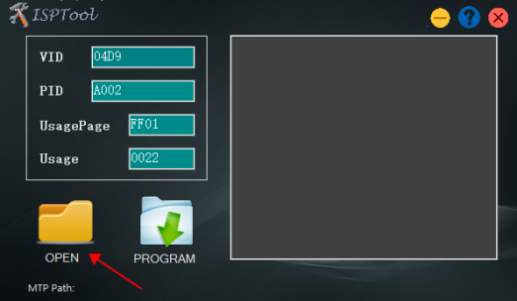 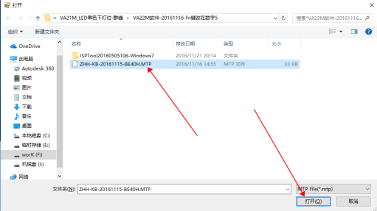

1. Start upgrading

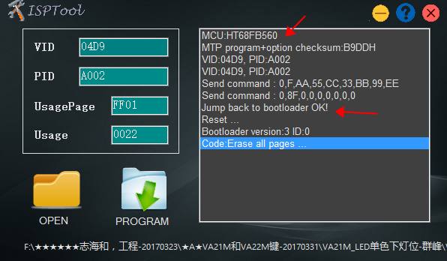

1. Success

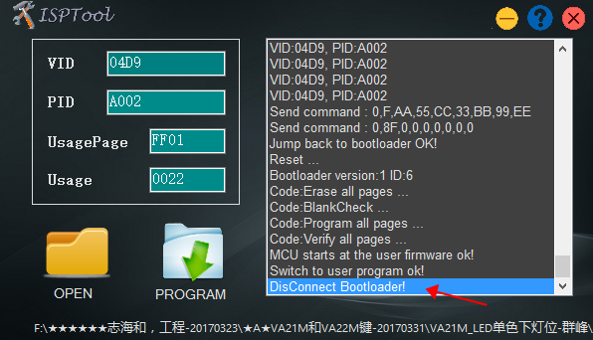12